Pledge Form
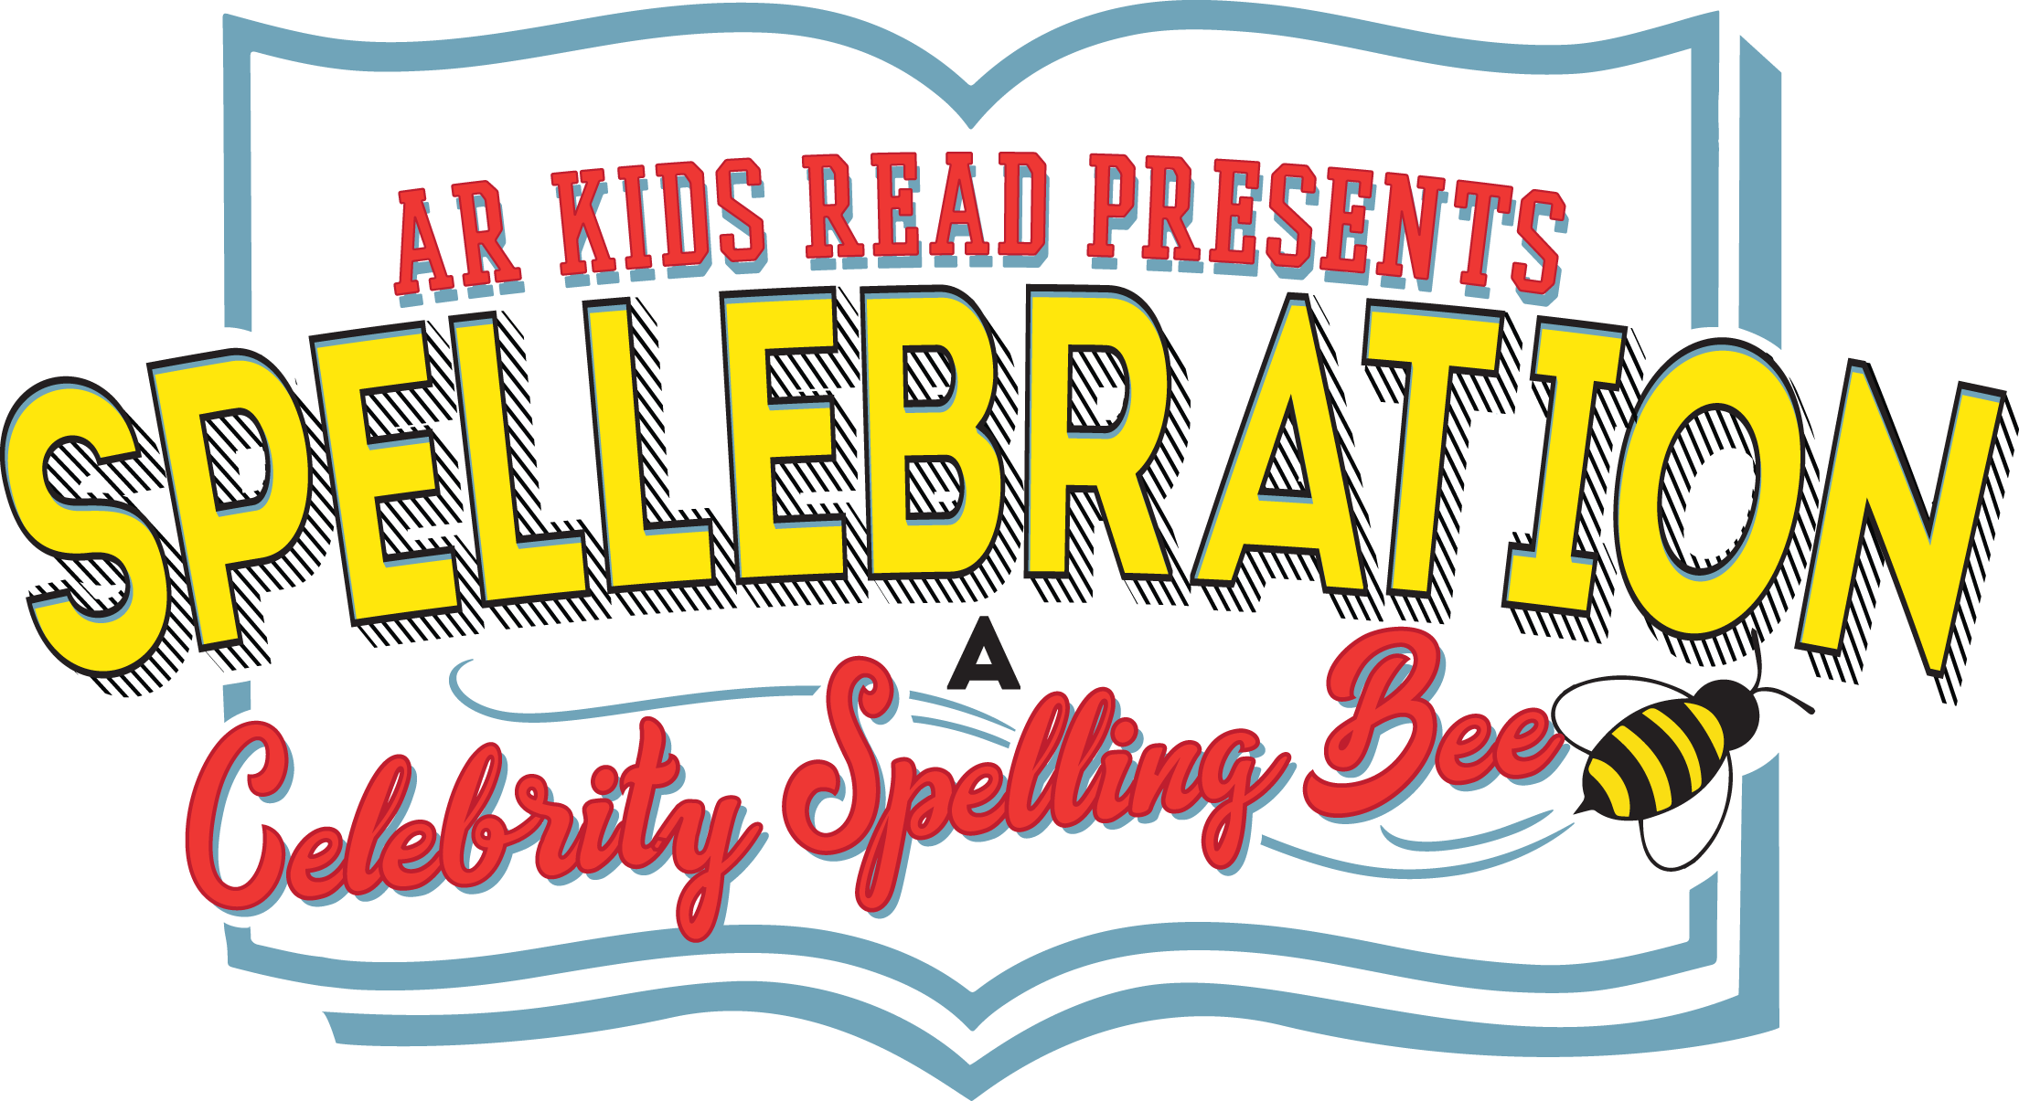 | AR Kids Read  Building Stronger Readers Builds a Stronger Community and Brighter Futures

Donor Information (please print or type)

Name

Billing address

City, ST Zip Code

Phone

Email

Pledge Information
I (we) pledge a total of $____________________ to be paid: ☐now ☐by March 4th.
I (we) will make this contribution in the form of: ☐cash ☐check ☐credit card.
NOTE: Please make credit card payments at www.arkidsread.org/donate.
Gift will be matched by (company/family/foundation)
☐form enclosed☐form will be forwarded

Acknowledgement Information
Please use the following name(s) in all acknowledgements:

☐I (we) wish to have our gift remain anonymous.

Signature(s) |  | Date
Please make checks, corporate matches,  or other gifts payable to: |  | AR Kids Read  P.O. Box 22701  Little Rock, AR 72221

